**AR VR ASSIGMENT**

***Title: AR/VR Gaming Room Assignment: Gem Hunt***

**Introduction In this assignment, we explore the development of an interactive AR/VR gaming room. Players will search for hidden gems that unlock a door, providing an engaging experience. This document outlines the game mechanics, setup, and the Unity scripts used.**

**Game Mechanics**

* **Objective: Players must collect a specified number of hidden gems.**
* **Unlocking the Door: Once the required number of gems is collected, the door will unlock, allowing players to exit the room.**

**Unity Setup**

1. **Scene Design:**
   * **Create a small room environment.**
   * **Place hidden gems throughout the room.**
   * **Create a door that players must unlock**
2. **STEPS**

* **FIRST OF ALL MAKING A NEW 3D PROJECT**
* **AFTER DOWNLOADING AND IMPORTING PACKEGES LIKE XR INTERACTION TOOLKIT**
* **NEXT STEP IS TO FIND ASSETS**
* **I HAVE IMPORT A LOWLY POLY ASSET AND GEMS ASSETS FROM ASSETS STORE**
* **AFTER I HAVE CREATE A ATMOSPHERE A ADDING SUNLIGHT AND A SKY**
* **IN ROOM I HAVE ADDED TABLE ,CHAIR,BOOKS,POTS ,BOXES IN WHICH WE HAVE TO FIND GEMS**
* **AFTER MAKING A GOOD ATMOSPHERE I HAVE HIDE GEMS**
* **WITH THE HELP OF XR ORIGIN,AND RIGHT AND LEFT HAND CONTROLLER WE CAN FIND THE GEMS**
* **WHEN A PLAYER FIND GEMS THE DOOR WILL OPEN**
* 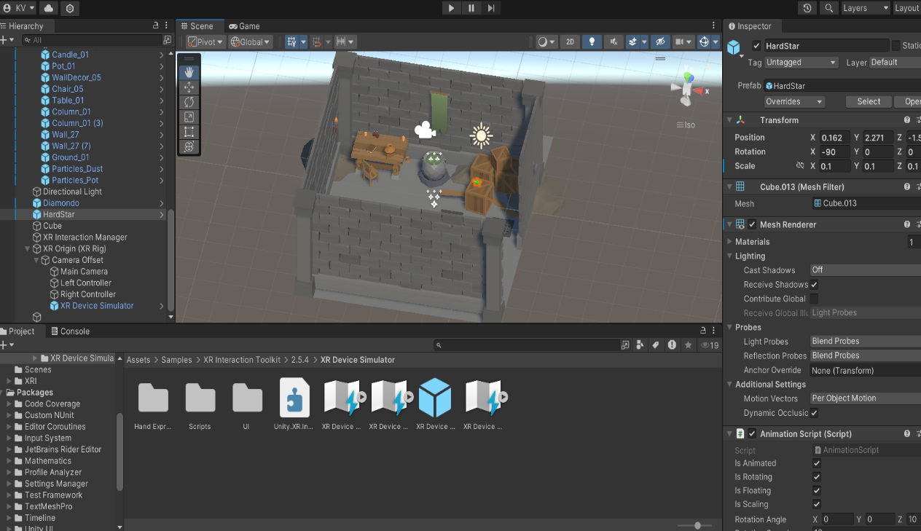
* **WITH THE HELP OF XR DEVICE SIMULATOR WE CAN CONTROL THE MOVING PART**
* **AT LAST I HAVE ADDED A COMFORT AUDIO FOR MORE INTERESTING**